Project Phase II: Cyberminer User Manual

*Version 2.0*

CS/SE 6362 Advanced Software Architecture (Fall 2015)

**Submitted to:**

**Dr. Lawrence Chung,**

**Associate Professor,**

**Department of Computer Science,**

**The University of Texas at Dallas,**

**Richardson, TX -75080**

**Submitted By:** Team Name: Quick Search

**Sruthi Chappidi,** [**sxc105920@utdallas.edu**](mailto:sxc105920@utdallas.edu)**,**

**Barbara Maweu,** [**bmk101020@utdallas.edu**](mailto:bmk101020@utdallas.edu)

**Maryellen Oltman,** [**mco130030@utdallas.edu**](mailto:mco130030@utdallas.edu)

**Twinkle Sharma,**[**txs151730@utdallas.edu**](mailto:txs151730@utdallas.edu)**.**

**Team Website:** [**www.utdallas.edu/~maryellen.oltman**](http://www.utdallas.edu/~maryellen.oltman)

The Application source code will be available on our team website. Welcome screen will be displayed with text box to enter the keywords, and dropdown list/checkbox for preferences.

**Cyber Miner System**

**Step 1: Select the search table to display below page and enter keywords to be searched.**

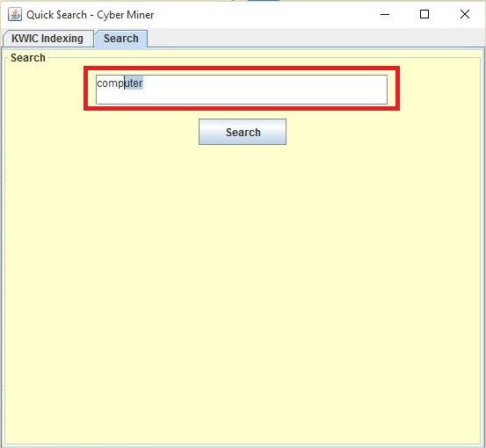

**Step 2: Click the ‘Search button to begin the process of searching and displaying the url related to the terms searched.**

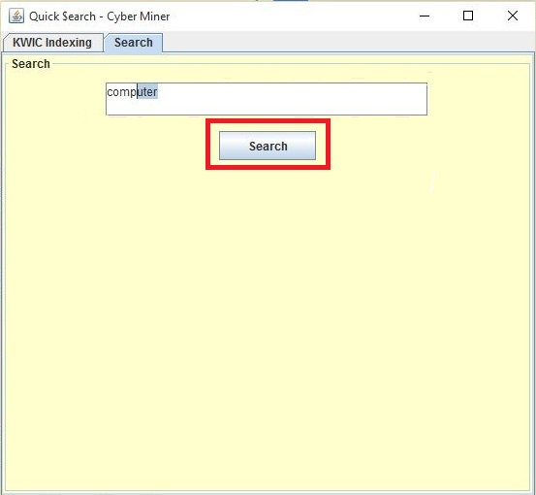

**Step 3: Browse the displayed search results.**

The number of search results per page may be selected from the ‘items per page’ by entering the text box.

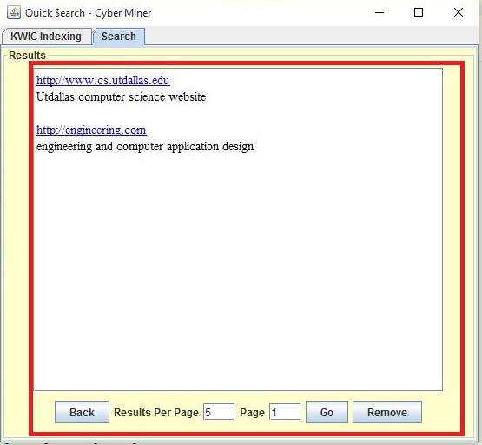

**Step 4: Report Broken/ Out-of-Date link**

By clicking the Remove button (from step3) , the report an url page will be displayed. By entering the url that you would like to report will make the website inactive and administrator will analyze and remove the reported link

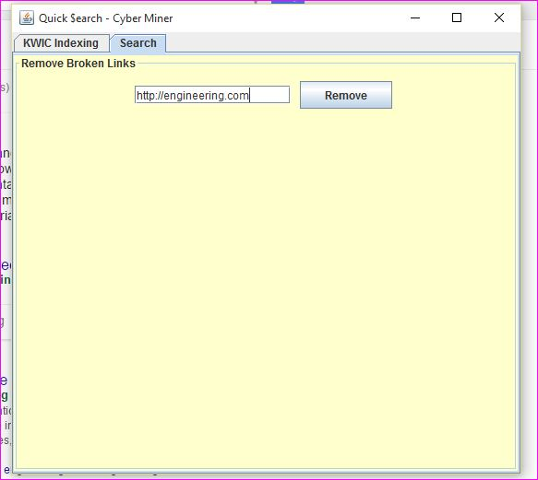

**KWIC Indexing**

**Step 5: KWIC indexing- Inputting the Entries**

By selecting the KWIC indexing tab, it will display welcome screen below to enter the url and description that the user would like to index. By clicking “Initial Entries” checkbox, the user will save the url as new and otherwise just update the description of earlier input

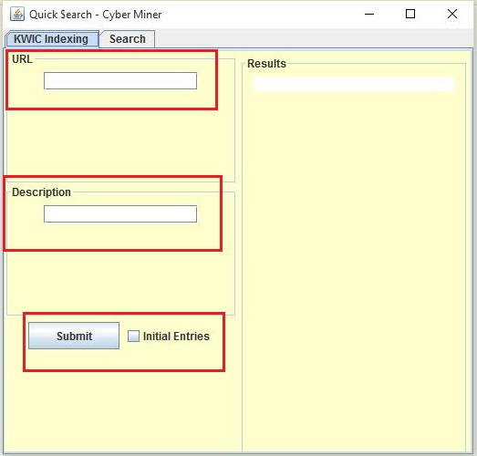

**Step 6: Circularly shifted and Alphabetically sorted list**

By clicking “submit” from step 5, the input description will undergo the steps and implmentation from phase 1 with KWIC indexing including: circular shift, remove noise words, alphabetically sort and then store the list in the database

